DBMS

**Task 1**

**Assumptions made are as Following:**

1. Each plane is identified by its unique registration number but plane models can have multiple plane registration numbers.
2. Every flight pass connects to AirPods the destination and arrival with a distinct light parts Number resigned to the Route.
3. Each flight instant has specific and a specific plane associated with it .
4. Each client has at least one attendant from abroad and is designated by flight service manager.
5. Each flight instance has at least two pilots and the pilot and co-pilot.
6. Some of the pilots are qualified to fly multiple plane models and some are qualified to play only one model of plane.
7. some flight attendance, mentor, flight attendance, and creator mentor mental relationship.

**Logical Diagram**

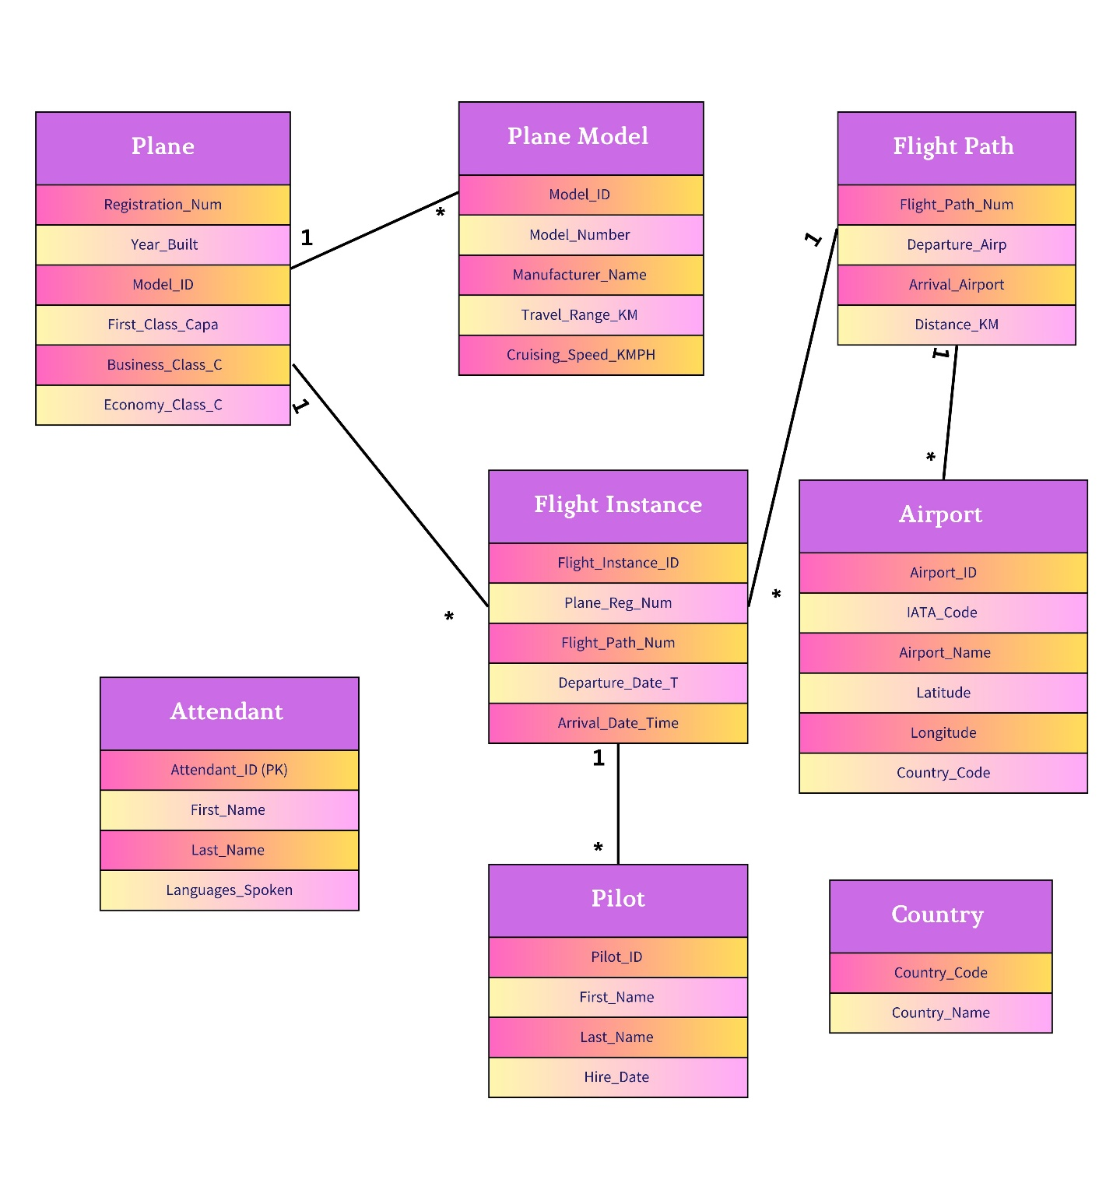

**Physical Diagram**

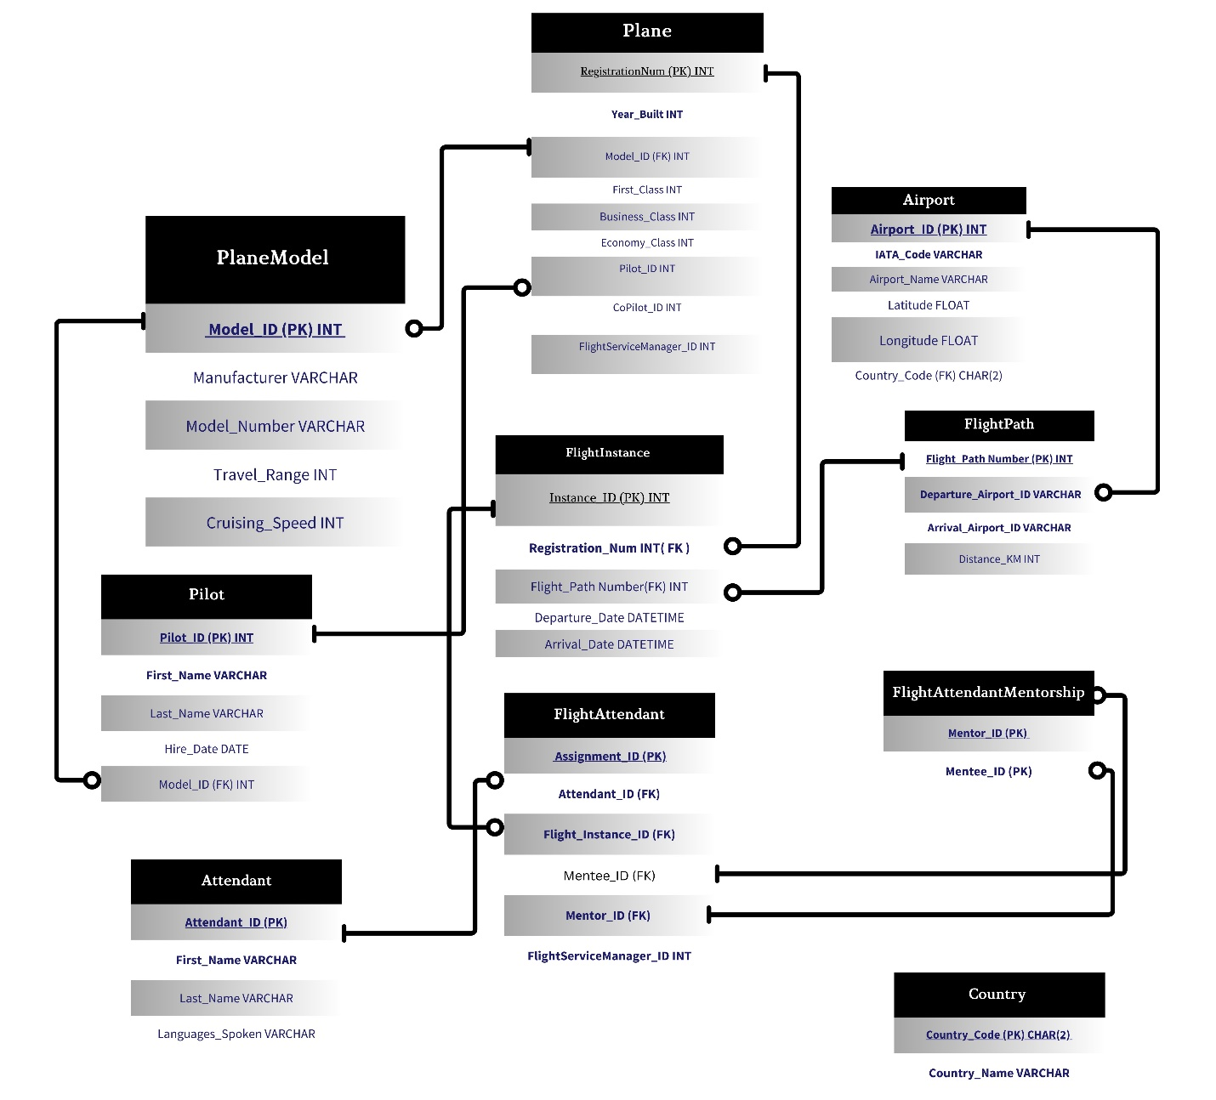

**Data Dictionary**

|  |  |  |  |  |
| --- | --- | --- | --- | --- |
| *Entity* | *Attribute* | *Data Type* | *Constraints* | |
| *PlaneModel* | Model_ID (PK) | INT | NOT NULL, Identity (1,1) | |
| Model_Number | VARCHAR | NOT NULL | |
| Manufacturer | VARCHAR | NOT NULL | |
| Travel_Range | INT | NOT NULL | |
| Cruising_Speed | INT | NOT NULL | |
| Model_ID (PK) | INT | NOT NULL, Identity (1,1) | |
| Model_Number | VARCHAR | NOT NULL | |
|  |  |  |  | |
| *Plane* | Registration_Num (PK) | VARCHAR | NOT NULL | |
| Year_Built | INT | NOT NULL | |
| Model_ID (FK) | INT | NOT NULL, Foreign Key (references PlaneModel(Model_ID)) | |
| First_Class | INT | NOT NULL | |
| Business_Class | INT | NOT NULL | |
| Economy_Class | INT | NOT NULL | |
| Registration_Num (PK) | VARCHAR | NOT NULL | |
| Pilot_ID | INT | Foreign Key (Pilot) | |
| CoPilot_ID | INT | Foreign Key (Pilot) | |
| FlightServiceManager_ID | INT | Foreign Key (FlightAttendant) | |
|  |  |  |  | |
| *FlightPath* | Flight_Path (PK) | INT | NOT NULL, Identity (1,1) | |
| Number | INT | NOT NULL | |
| Departure_Airport | VARCHAR | NOT NULL | |
| Arrival_Airport | VARCHAR | NOT NULL | |
| Distance_KM | INT | NOT NULL | |
|  |  |  |  | |
| *FlightInstance* | Instance_ID (PK) | INT | NOT NULL, Identity (1,1) | |
| Registration_Num (FK) | VARCHAR | NOT NULL, Foreign Key (references Plane(Registration_Num)) | |
| Flight_Path (FK) | INT | NOT NULL, Foreign Key (references FlightPath(Flight_Path)) | |
| Departure_Date | DATETIME | NOT NULL | |
| Arrival_Date | DATETIME | NOT NULL | |
|  |  |  |  | |
| *Airport* | Airport_ID (PK) | INT | NOT NULL, Identity (1,1) | |
| IATA_Code | VARCHAR | NOT NULL | |
| Airport_Name | VARCHAR | NOT NULL | |
| Latitude | FLOAT | NOT NULL | |
| Longitude | FLOAT | NOT NULL | |
| Country_Code (FK) | CHAR(2) | NOT NULL, Foreign Key (references Country(Country_Code)) | |
|  |  |  |  | |
| *FlightAttendant* | Attendant_ID (PK) | INT | NOT NULL, Identity (1,1) | |
| First_Name | VARCHAR | NOT NULL | |
| Last_Name | VARCHAR | NOT NULL | |
| Languages_Spoken | VARCHAR | NOT NULL | |
| FlightServiceManager_ID | INT | FOREIGN KEY (REFERENCES FlightAttendant(Attendant_ID) | |
| Mentor_ID (FK) | INT | NOT NULL | |
|  |  |  |  | |
| *FlightAttendantMentorship* | Mentor_ID (PK) | INT | NOT NULL, Foreign Key (references FlightAttendant(Attendant_ID)) | |
| Mentee_ID (PK) | INT | NOT NULL, Foreign Key (references FlightAttendant(Attendant_ID)) | |
|  |  |  |  | |
| *Country* | Country_Code | CHAR(2) | | Not Null, Identity (1,1) |
| Country_Name | VARCHAR(100) | Not Null, Identity (1,1) | |
|  |  |  |  | |

**Task 2**